Computer networks

**Lab activity – 9**

**Name :** N.V.M.Sumanth

**Reg no :** 192111449

**Faculty :** Dr. S. Ramesh

**Course code :** CSA0786 computer networks for wanet applications

**Lab activity : 9**

**Question - Functionalities of TCP, UDP.**

**Step 1 : take one server**

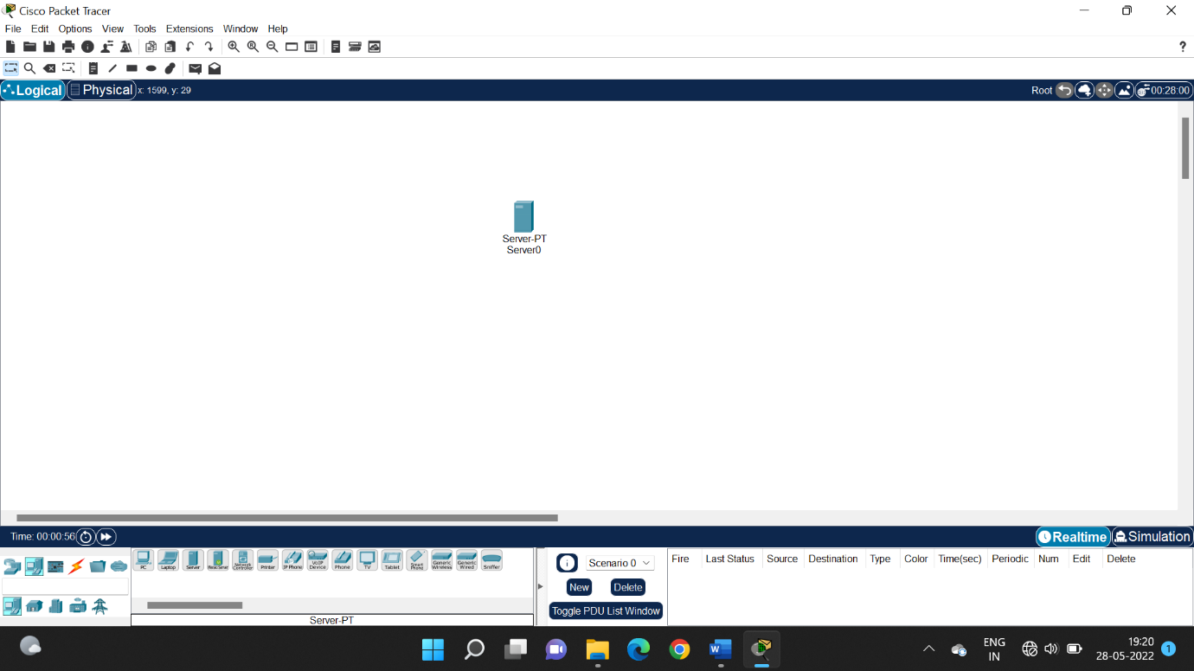

**Step 2 : take one switch**

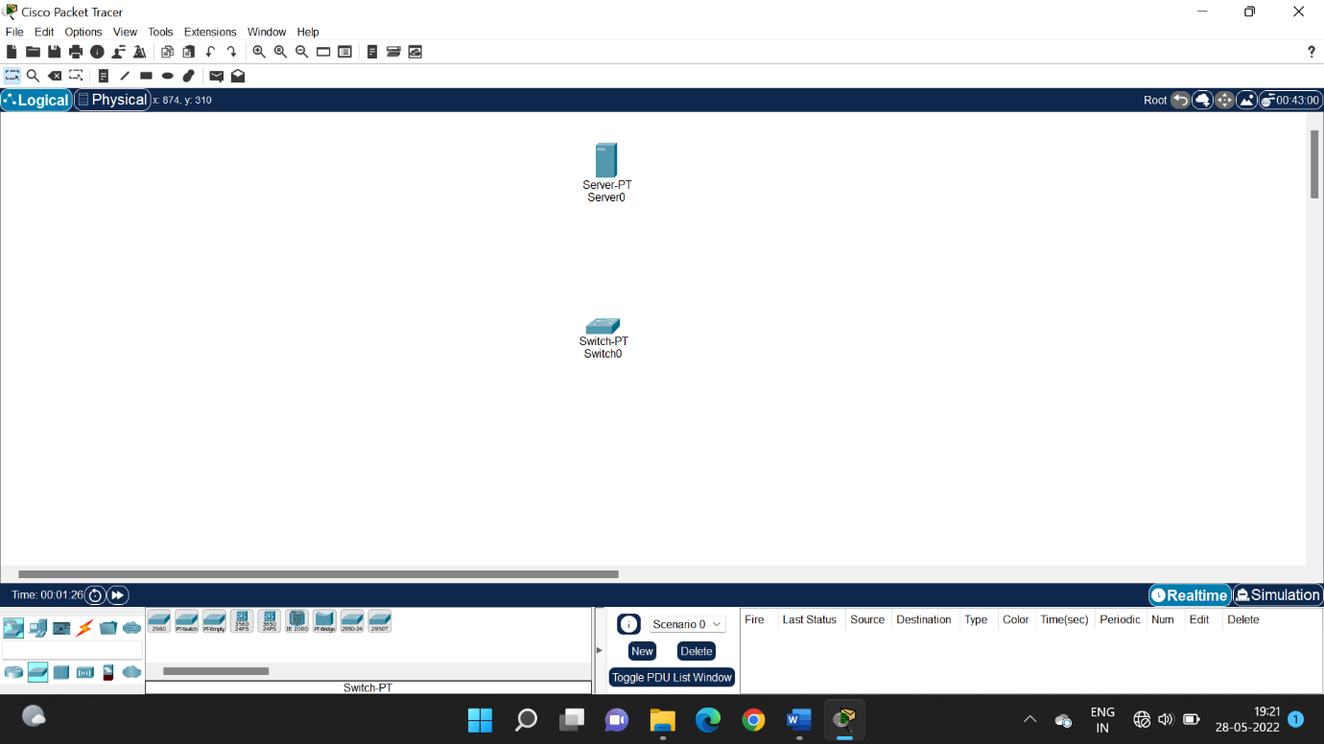

**Step 3 : take 3 pc’s and connect all the switches and systems**

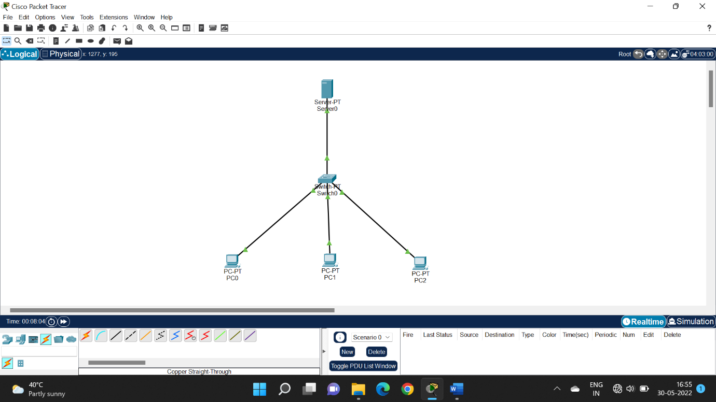

**Step 4 : configure IP address and default gateway to server**

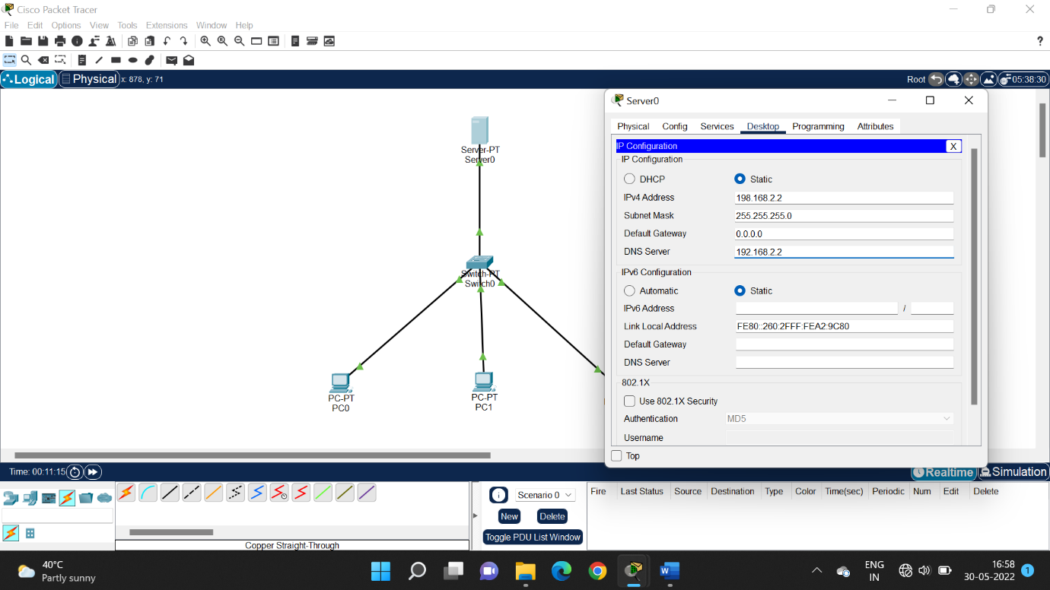

**Step 5 : configure IP address and default gateway to all the systems**

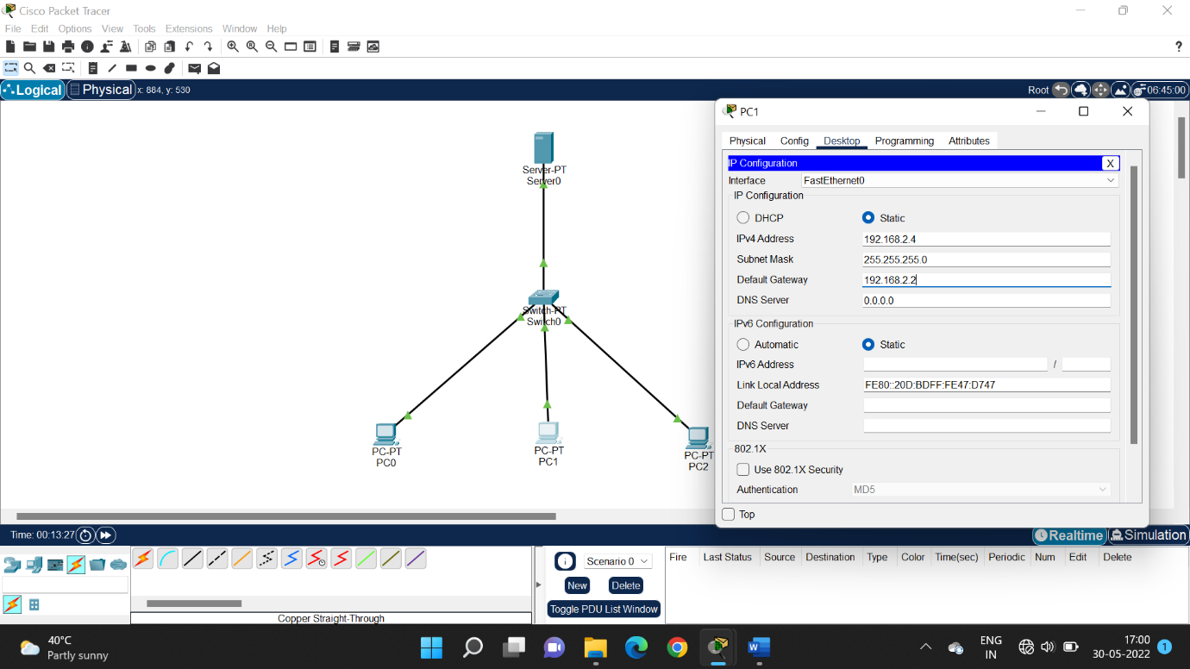

**Step 6 : ping IP address 198.162.2.3 in server 0**

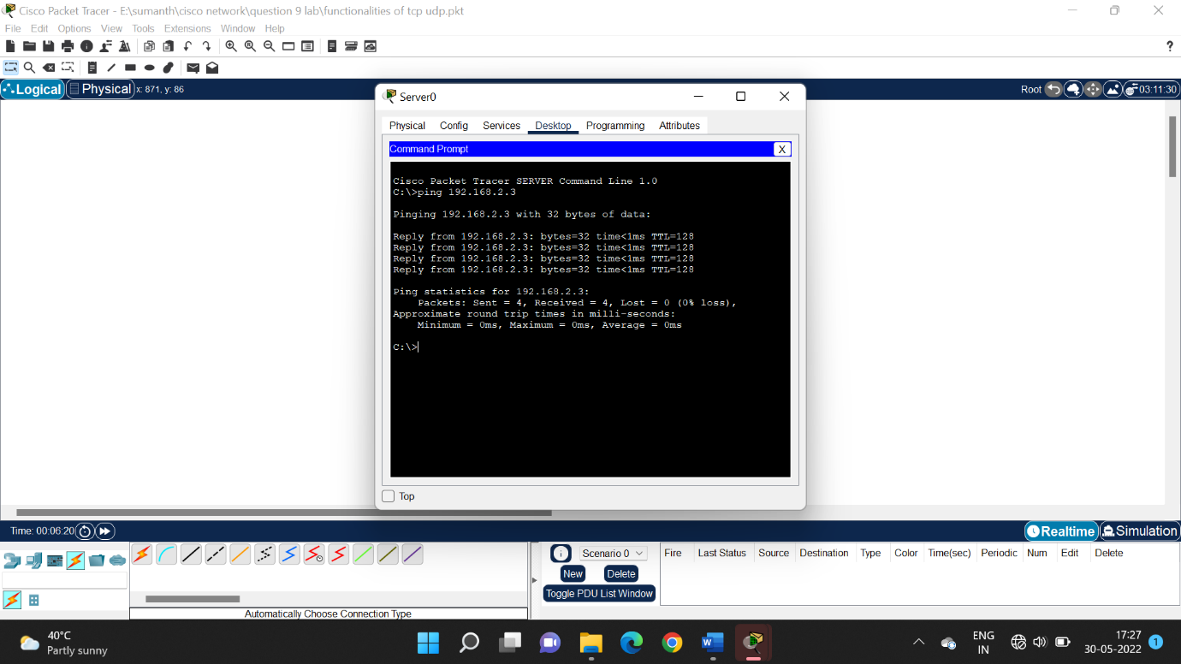

**Step 7 : run Ip address 192.168.2.1 in configuration web browser of pc 2**

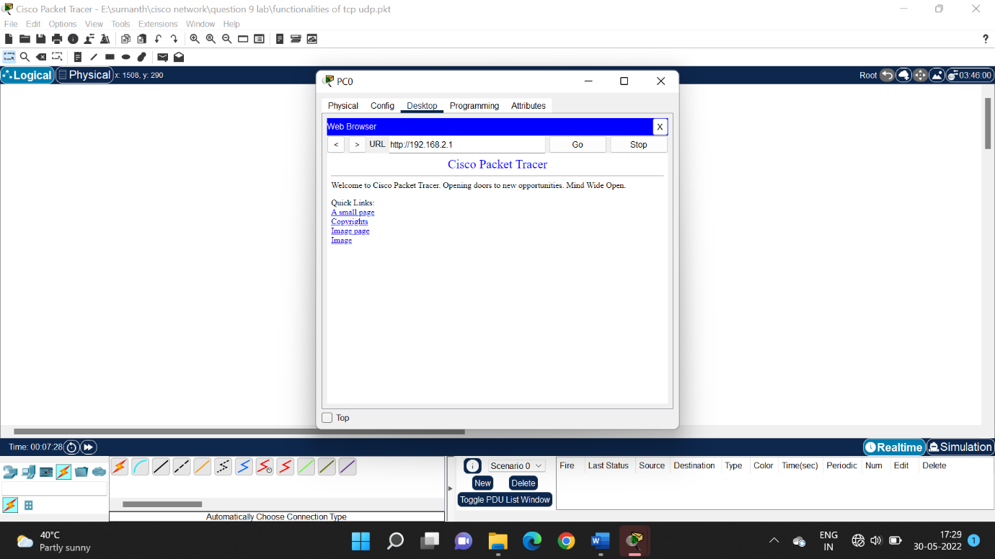

**Step 8 : try to connect pc 1 to ftp server through IP address of 192.168.2.4**

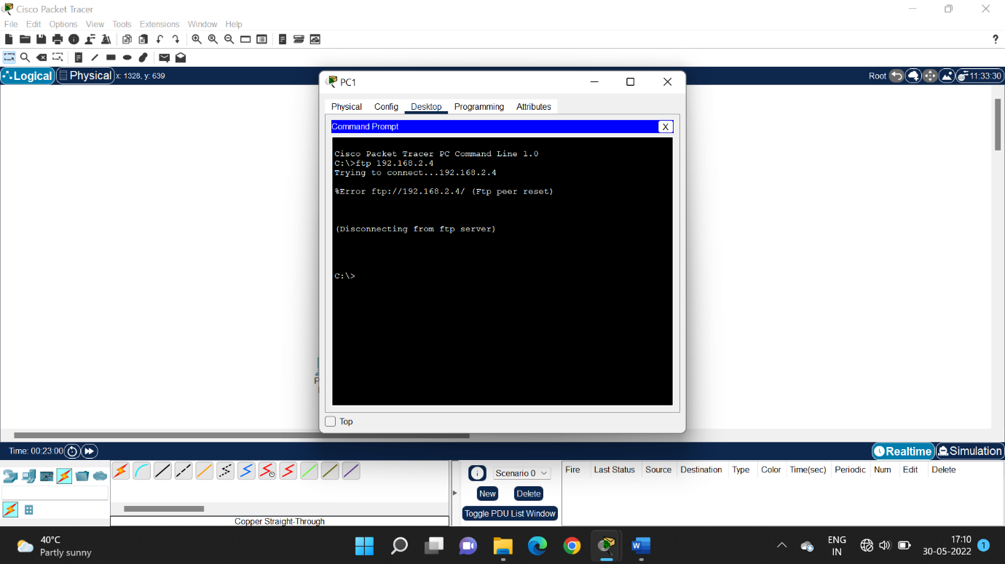

**Step 9 : run the system and check acknowledgement**

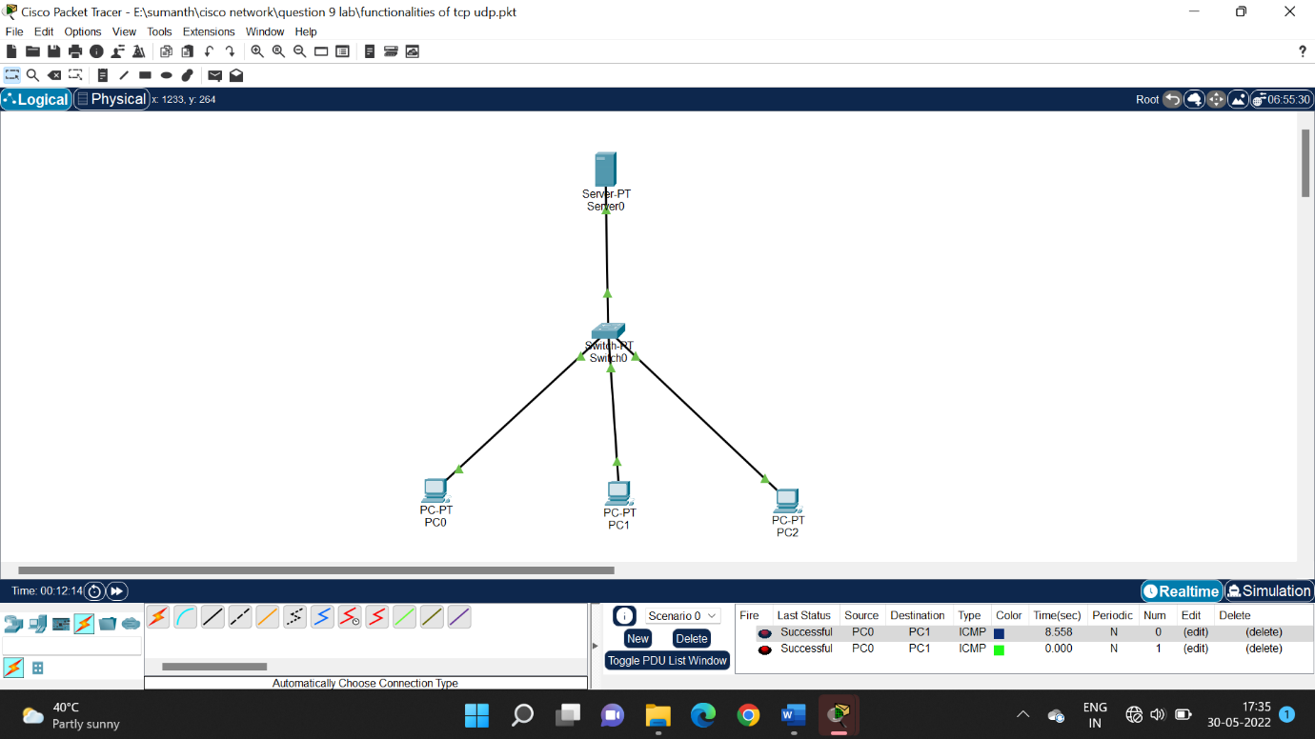

**Lab activity : 9**